|  |  |  |  |  |  |  |
| --- | --- | --- | --- | --- | --- | --- |
| |  | | --- | | **School of Engineering & Physical Sciences**  **Department of Electrical and Computer Engineering (ECE)** |  |  | | --- | | **Final Project Report**  **CSE 299: Junior Design**  **Section – 18**  **Summer 2021** |   **Prepared date:- 02 September 2021**   |  |  | | --- | --- | | **Submitted By** | **Submitted to** | | Name:Moasrrat Shazia Kabir  ID: 1831228642  Syeda Karishma Naaz  ID-1831270642 | Dr. Ziaul Hossain (ZHO)Sir | |

**Acknowledgment**

**We would like to express our special thanks of gratitude to Ziaul Hossain (ZHO) Sir, who allowed us to do the wonderful project on JUNIOR DESIGN PROJECT (CSE299), which also helped us in Research, and we came to know about so many new things. We are thankful for him. It is his guidance and patience that led us to envision our project “Online Event Organizer” to be a full-fledged solution for an online Event management system.**

**Abstract**

We have been working on “Online Event Organizer” which is a web-based application that would help users to find their suitable event plans, wedding plans, booking convention halls, photographers, and catering services. Initially, we spotted difficulties in the execution of our project idea and setting up our project beautifully. So, we did research and took some conceptions from the internet. We also visited those event-organizing websites which are already well established in the market. When we started doing our project, we faced difficulties with programming languages. In our previous research, we got some options about programming languages. We selected the PHP programming language to work. For the frontend-backend design purpose, we used HTML, CSS, and Bootstrap CSS framework. As for the database, we used the MySQL server. The development environment was the XAMPP server. We used Microsoft Visual Studio as our code editor. In this project, the admin has all the access, and users can make appointments for their event within their budget. Users have the opportunity to customize their events. We show the effectiveness of our idea by showing its options and choices. We also showed the facilities for users. Technical System is fast, reasonable, and user friendly. The proposed system enables the customers to do things such as the search for available services. The system displays all the descriptive details for the services, such as a price, offers, appointment button. Users can make or cancel appointments at any suitable time. There is no need to wait for a slot. Once a user fills up the appointment form, he will get a confirmation message showing the appointment details.

**Introduction**

The main aim of this project is to develop a web-based application for organizing events. This application will lead to an easy life for those who want to organize any event or celebrate their special days but cannot arrange them for many reasons. It is tough to find a proper event plan besides a time-consuming process. People usually have to start their planning 2-3months ago from an event. There is always a hassle to organize any event. Nowadays, pandemics have become one of the main reasons to skip an event or cancel special events. With the help of this project, People can easily manage their functions. The application should control all the processes so that every user will get equal service. Even Working people can arrange any occasion online.

We have chosen an online event organizer because everything is on the internet but, some fields haven't improved it. Some research shows that the percentage of formal or informal events has increased in the last two years. Every convention hall needed to be booked before six months to one year ahead of the event. But if anyone plans for any event, they have to talk individually with the convention hall, catering services, decorators, and photographer. Most people aren't satisfied with the event because of the lack of planning, unprofessional work.

Our goal is to plan an event according to the client's requirements and provide all the facilities in one terminal.

**Features:**

•Each service (Events) is categorized so that users can find their expected service easily.

•Users can find various services or event plans.

•For an appointment or booking, a user needs to fill a simple form.

•Users can write their valuable reviews.

•Users can cancel an appointment with an ensuring message.

•Users can see the admin details on the contact page.

•The admins have to log in to see the details and can change his/her password.

•Admins can edit the categories/services image, price, descriptions, active status, appointment status, etc.

**Background**

We have been working on Online Event Organizer, which is a web-based application for organizing any events. Research on the well-establish event organizing websites was needed to develop this application. Again some research and experimentation on different tools to find suitable ones in development work are required.

**Used tools and language:**

**Microsoft Visual Studio:**

Microsoft Visual Studio is an integrated development environment from Microsoft. It is used to develop computer programs, as well as websites, web apps, web services, and mobile apps. The purpose of using this code editor was the flexibility in use. Any programming language can be edit by using this code editor.

For the development of the Online Event Organizer, version 16.10.1(2019) ware used.

**Reference:**

<https://code.visualstudio.com/download> (Download link)

**XAMPP Server:**

XAMPP is a free and open-source cross-platform web server solution stack package developed by Apache Friends, consisting mainly of the Apache HTTP Server and interpreters for scripts written in the PHP and Perl programming languages.

The Online Event Organizer is developed using PHP programming language and MySQL server; XAMPP was the most efficient and suitable for this web-application.

The XAMPP server for this web-application was Version 3.2.4 (2019).

**Reference:**

<https://www.apachefriends.org/download_success.html> (Download link)

**MySQL:**

MySQL is an open-source relational database management system.

MySQL server ware used to design the database for the Online Event Organizer and the version was MySQL workbench v8.0.

**Reference:**

<https://dev.mysql.com/downloads/windows/installer/8.0.html> (Download link)

**Bootstrap:**

Bootstrap is a free and open-source CSS framework directed at responsive, mobile-first front-end web development. It contains CSS- and JavaScript-based design templates for typography, forms, buttons, navigation, and other interface components.

The bootstrap framework was used to design the forms and data-tables, and buttons of the Online Event Organizer front-end and backend pages. The used Bootstrap version was Bootstrap v4.

**Reference:**

<https://getbootstrap.com/docs/4.0/getting-started/download/> (Download link)

**HTML:**

The Hypertext Markup Language or HTML is the standard markup language for documents designed to be displayed in a web browser. It can be assisted by technologies such as Cascading Style Sheets (CSS).

For the structure Of the Online Event Organizer, HTML5 was used.

**Reference:**

<https://www.w3schools.com/html/>

**PHP programming language:**

PHP is a general-purpose scripting language geared towards web development. The Online Event Organize web application was develop using PHP version 7.4.16. The purpose of using PHP programming language was, it can be embedded, into HTML and it is easier to add functionality to web pages without needing to call external files for data.

**Reference:**

<https://windows.php.net/download#php-7.4> (Download link)

**Methodology**

**Architecture Diagram:**

This diagram is showing how users can interact with the web application. It represents the use of HTML and CSS in the front-end, PHP and XAMPP as web-server, the use of File systems and Databases in the backend, and the interaction between them.

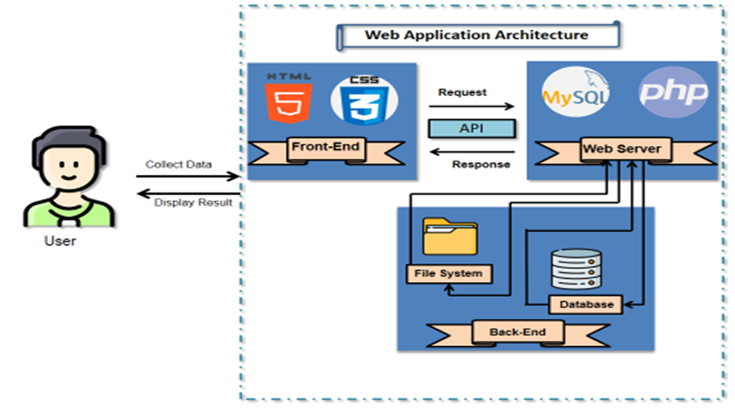

Figure-01: The Architecture Diagram for Online Event Organizer.

**Class Diagram:**

The class diagram shows the main class and its attributes for the application. The admin has access to every class. The admin can delete and edit the categories and events, see reviews, and update the appointment status.

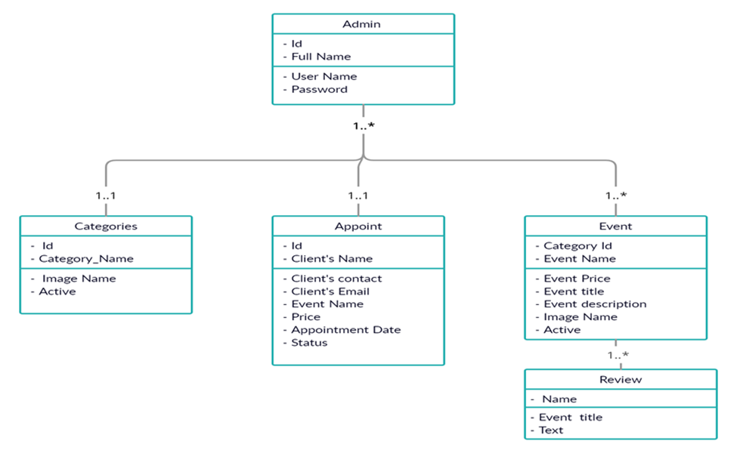

Figure-2: The Class Diagram for Online Event Organizer.

**ER Diagram:**

The ER diagram shows the entries in rectangular shape (Admin, Category, Events, Appointment, and Reviews), their attributes in oval shape. The relationship between the entries are represented by the diamond shape.

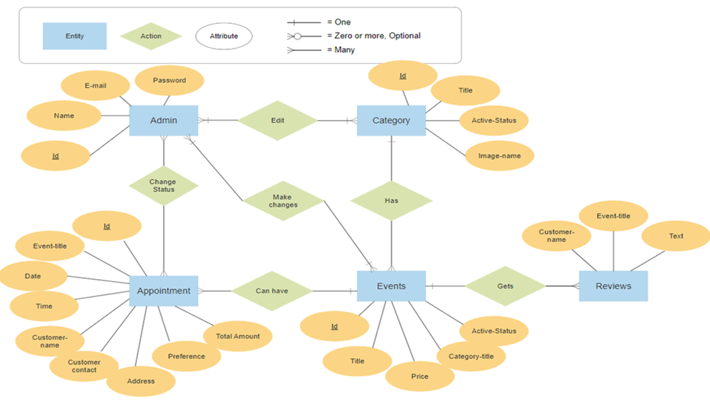

Figure-3: The ER Diagram for Online Event Organizer.

**Results**

**Front-end Design:**

The Online Event Organizer's front-end was designed using HTML and CSS along with six individual web pages. Every web page contained the menu, social, and footer sections in common. Each web page is connected.

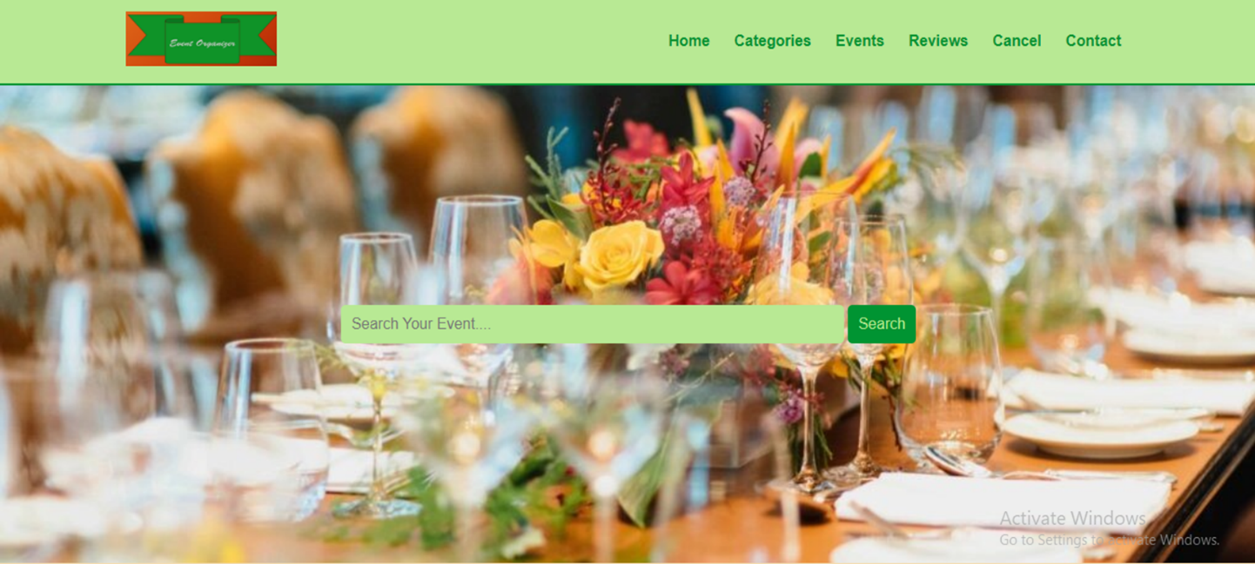

Figure-4.1: The Home-page of Online Event Organizer (Menu and Search section)

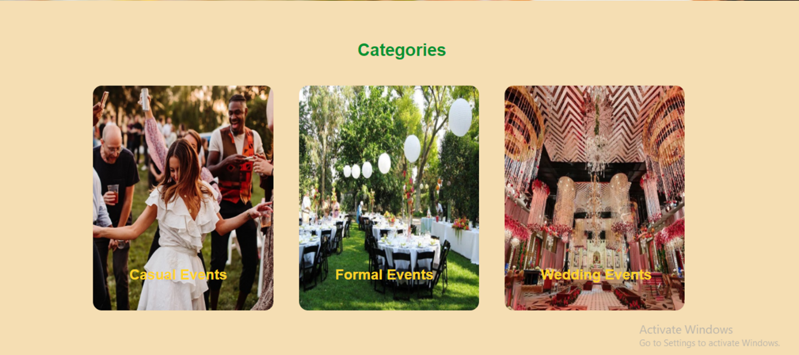

Figure-4.2: The Category section of Online Event Organizer

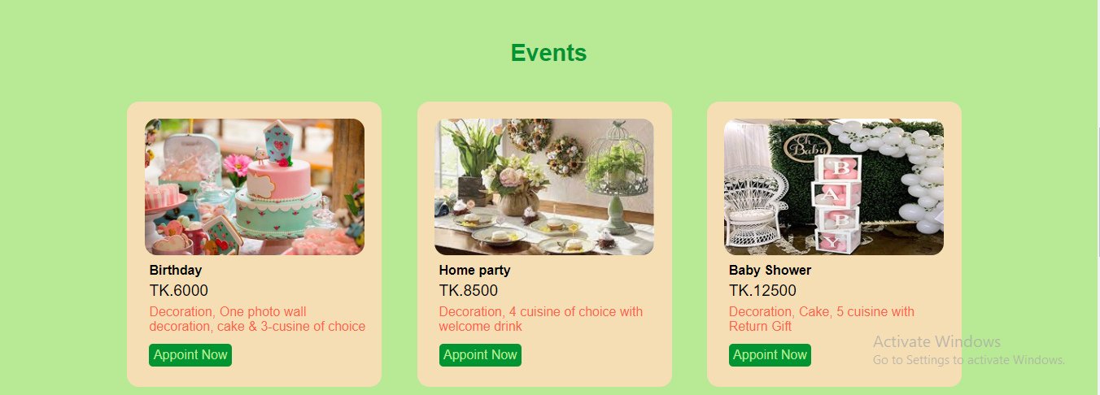

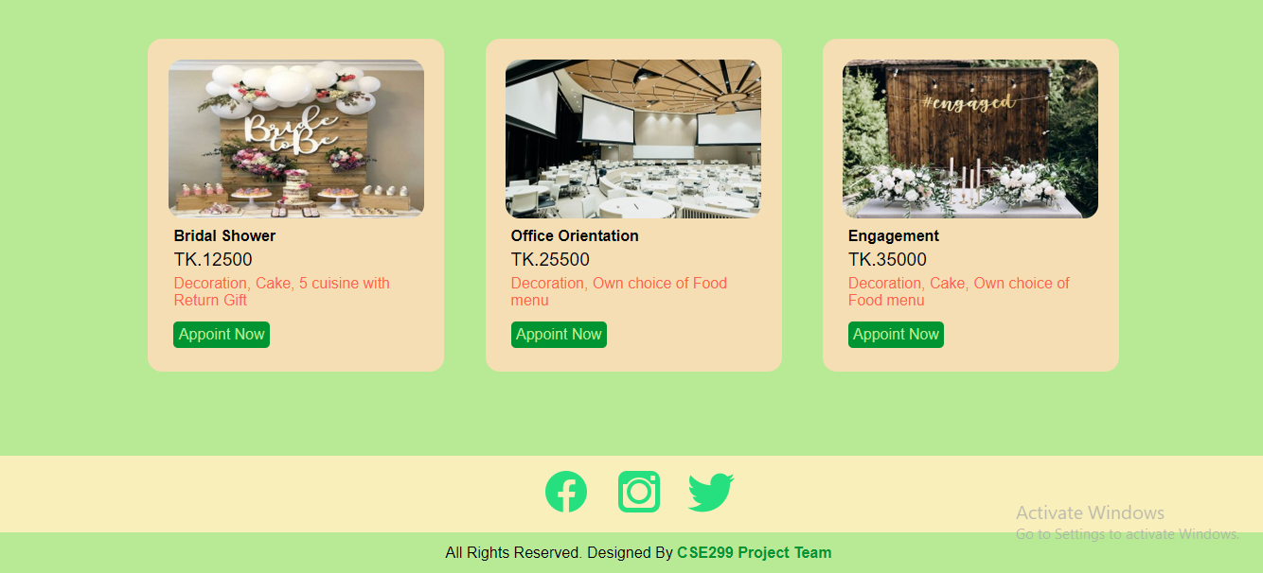

Figure-4.2: The Event section of Online Event Organizer

**Forms in front-end:**

The Online Event Organizer's front-end contained two forms. One for making an appointment and another for adding reviews.

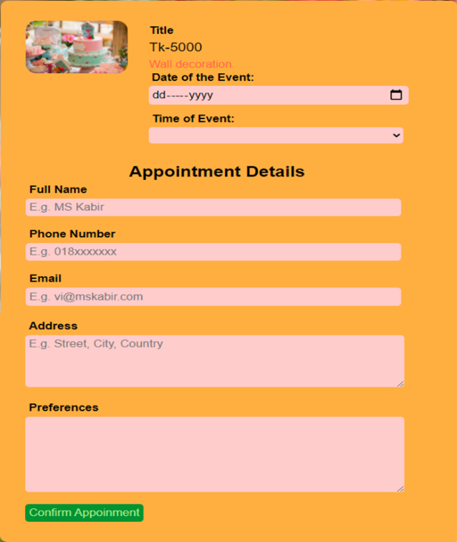 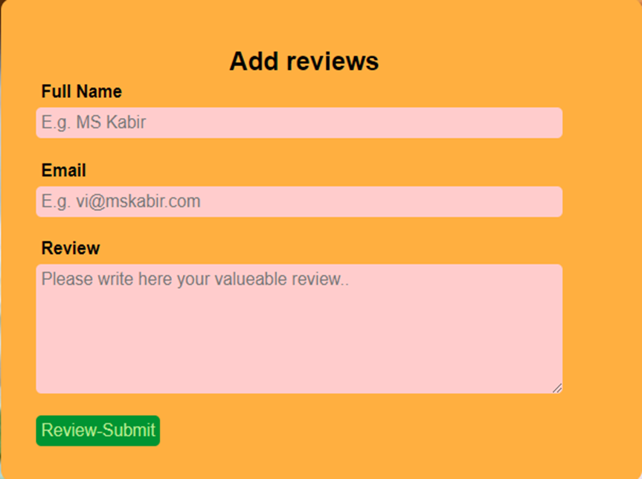

Figure-5: Appointment form and Review form of Online Event Organizer

**Back-end:**

The Online Event Organizer's back-end was designed using PHP programming language and Bootstrap framework. The back-end contained eight individual web pages. Every web page contained the menu and footer sections in common. Each web page is correlated.

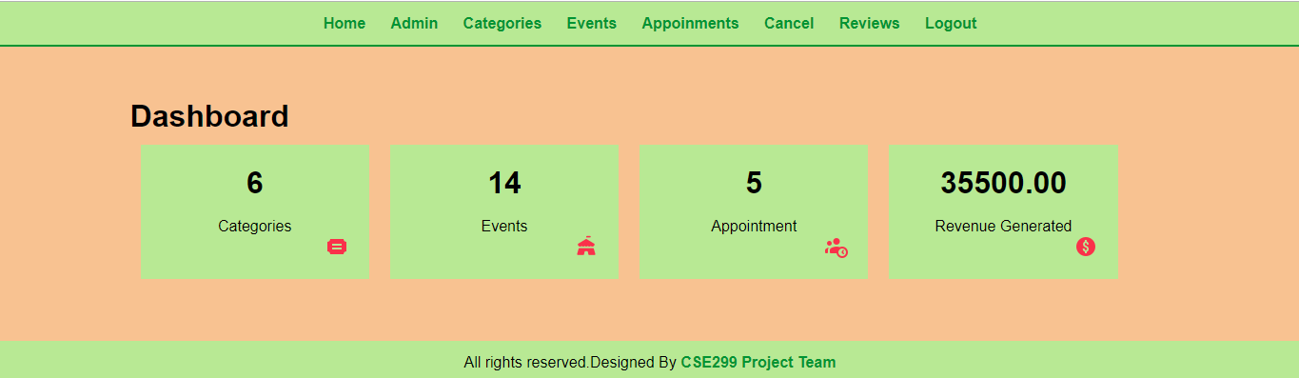

Figure-5: Dashboard of Online Event Organizer

**Database design:**

The Online Event Organizer's database was designed by using MySQL server and developed in local host PHPMyAdmin. The database contained six tables.

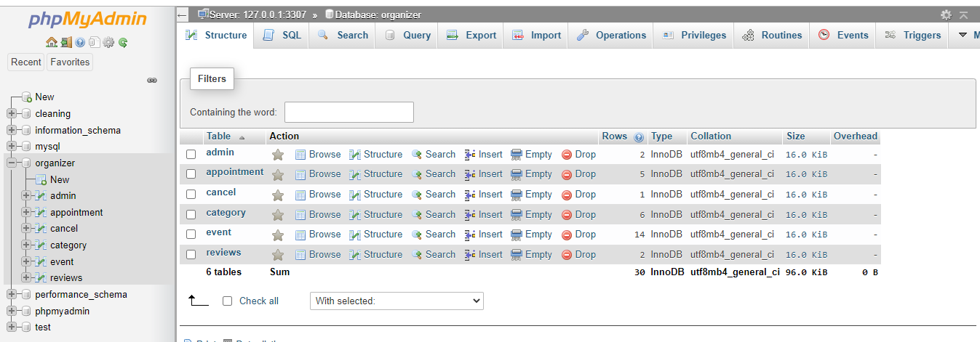

Figure-5: Database of Online Event Organizer

To get a more detailed idea about the Online Event Organizer, one should visit the given GitHub repository- **https://github.com/mosarrat/-mosarrat-CSE-299-Project-Online-Event-Organizer.git**

**Discussion**

We have been working on Online Event Organizer, which is a web-based application for organizing any events. At the very beginning, we made a Gantt chart and proceed according to that. While working on this project we spotted some difficulties.

The first problem we faced while implementing the review page. On this page, we wanted to use different icons and emojis, but we couldn't find any free website which would provide us with suitable icons. So, to get rid of this problem, we decided to build a text review page with basic HTML and CSS.

The second problem we faced while making the appointment form. We were trying to make such a form, that would match the color concept of our website, but basic HTML couldn't provide such facilities. Therefore, we had to write some customize CSS to make those forms.

The last problem we faced was when we started to use Bootstrap CSS for the back end. Although we build customize CSS for the back-end, we couldn't disable some features of Bootstrap CSS. Then we did some research and found that we had to link the customize CSS after the Bootstrap CSS.

While connecting the front end and back end of the web application, we faced some issues. We couldn't display the information from the back end to the front end. Then we decided to go through all the SQL codes and found the error. There was a wrong table attribute that caused that issue. We deleted that attribute and completed our connecting stage.

**Conclusion**

As mention earlier, we worked on the Online Event Organizer web application. We spotted few challenges at the beginning, by doing research, we had succeeded in those challenges. Currently, our web application is working considerably smoothly and swiftly. While working on the design process, we learned about different types of UML (Unified Modeling Language) diagrams. We have gone through various software such as ER plus and Smartdraw to draw those diagrams. The web application is completely developed in the PHP programming language. Designing this application enable our knowledge of the PHP programming language to be more potent.

The Strength of this web application is that it reduces user's hassle and time consumption. This application is user-friendly, the user can facilely explore it, and all the systems are easy to understand.

The weakness of the Online Event Organizer is that it does not grant any user or admin account. Admins have to log in to the back end, and it secures the system but does not the admin or user's personal information.

As mentioned earlier, the Online Event Organizer is a user-friendly web application. To get the service or get an appointment, one has to visit the website. Users can find their expected service or event inside the respective event category, event page or search the event name in the search bar. Every event option contains an appointment button clicking on that will redirect to the appointment form. Filling that form and clicking on the confirm appointment button will receive user appointments and display a confirmation message.

The admins can easily update and delete any category and event, change appointment status. They can decide which user review is allowed on the website and make any visual changes in the front-end and back end.

**Recommendation**

* For the front end, we recommend developing the user account system to protect the user's privacy. It will require some individual web pages along with the registration, sign-up forms.
* A cart system might enhance the beauty and usability of the website.
* As the back end, an individual admin account will make the system more secure and stable.

**References**

1. Bassett Events (2001) *Bassett Event Inc.* Available at: <https://www.bassetteventsinc.com/> (Accessed: 11 July 2021).
2. BDWEDDIING(2013) *Enchanted Events and Prints* Available at:

<https://bdwedding.com/vendor/wedding_planner/enchantedevents/> (Accessed: 19 July 2021).

1. W3Schools (copyright 1999-2021) *W3 School HTML* Available at: <https://www.w3schools.com/html/html_basic.asp> (Accessed: 02 August 2021).
2. W3Schools (copyright 1999-2021) *W3 School PHP* Available at: <https://www.w3schools.com/php/php_syntax.asp> (Accessed: 14 August 2021).
3. W3Schools (copyright 1999-2021) *W3 School SQL* Available at: <https://www.w3schools.com/sql/sql_syntax.asp> (Accessed: 25 August 2021).
4. Bootstrap (2011) *Bootstrap 4* Available at: <https://getbootstrap.com/docs/4.1/content/reboot/> (Accessed: 14 August 2021).